***The University of Texas at Dallas - Naveen Jindal School of Management***

**Conagra Brands Report**

**Group 14:**

**Chris Espino, Shanvi Shivali Kothapalli, Bhavith Akula, Sai Nikhel Rangala, Meet Pramod Saraswat, Swati Sutradhar**

**BUAN 6337.001**

**Professor: Shervin Shahrokhi Tehrani.**

**2024**

**Table of contents**

1. **Introduction**
   1. **Conagra Introduction**
   2. **Market Overview**
   3. **Market Trends**
   4. **Motivations of Consumers**
   5. **Project Objective**
   6. **Research Questions**
2. **Data preprocessing and Modelling**
3. **Data Analysis for Research Questions and Marketing Strategies**
   1. **Flavors**
   2. **Packaging**
4. **Conclusion**
5. **References**

**1. Introduction**

1. **Conagra Introduction**

Conagra Brands, Inc. is an American consumer packaged goods company headquartered in Chicago, Illinois. Conagra primarily operates in the United States, with operations within Canada and Mexico as well. They are the producer of many easily recognizable food brands, such as Slim Jim, Reddi-Wip, Pam, Chef Boyardee, Bertolli, Orville Redenbacher's, and many more. In addition to these well-known brands, Conagra also sells meat alternative products under the brand name Gardein. Gardein is Conagra’s premier meat alternative brand, which they are looking to optimize by accelerating its growth while also optimizing its extensive offerings to establish a stronger foothold in the meat alternative space.

1. **Market Overview**

The increase in the regular consumption of meat alternatives has been fueled by the global shift towards plant-based diets, which will be further expanded on later in this report. In the United States, the meat alternatives market has grown 11.3% CAGR within the past 3 years regarding USD sales and 3.8% CAGR regarding unit sales. Despite this growth in demand, there are consumer expectations that must be met for growth to continue. Meat alternatives must meet the expectations of consumers within the following three categories: flavor, texture, and overall appeal (Xu et al., 2022).

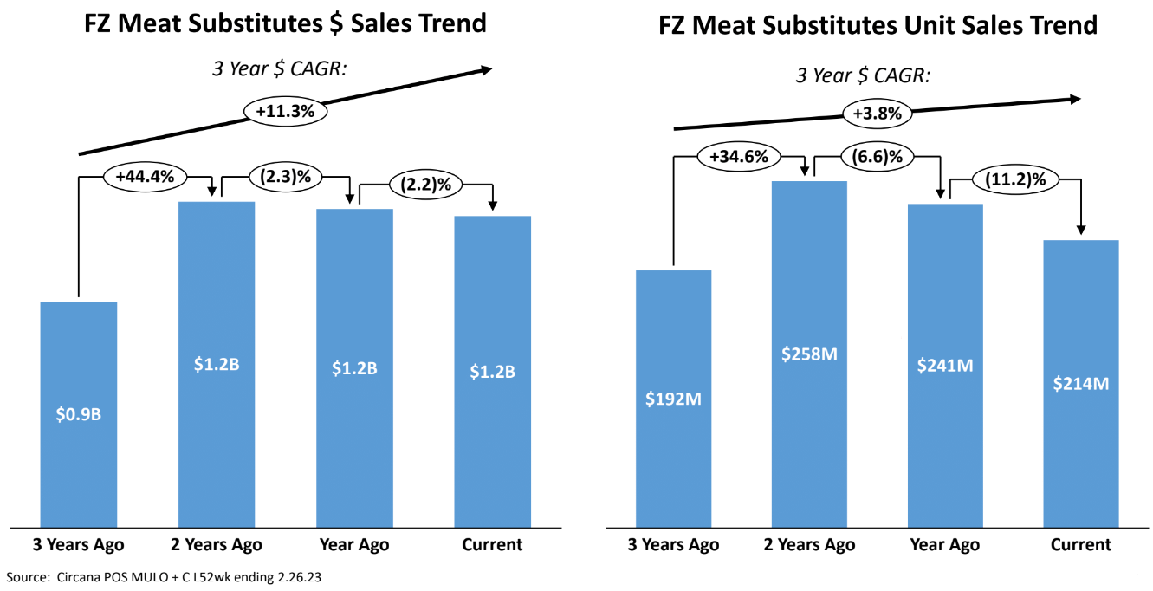

1. **Market Trends**

Meat alternatives are primarily appealing to individuals with the following diets:

* **Vegans and Vegetarians:** Vegans and Vegetarians consume meat alternatives primarily due to increased awareness towards ethics regarding food consumption and their health.
* **Flexitarians:** Flexitarians are likely introduced to meat alternatives through their friends and family who are either vegan or vegetarian. Through them, Flexitarians can sample meat alternatives and their qualities. This could drive them to introduce meat alternatives within their regular diet.

In addition to diet, the rapid expansion of the refrigerated segment in grocery stores plays a part in the increased popularity of meat alternatives. Market research conducted by Precedence Research shows that the demand for refrigerated display cases will only increase in the coming years (Precedence Research, 2024).

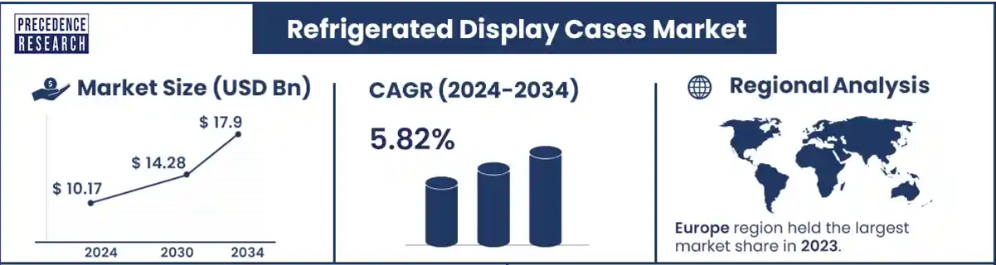

1. **Motivation of Customers**

Research indicates that there are several driving factors behind the purchasing of meat substitutes. We’ve decided to focus on the four following factors:

* **Price and value:** Price is a consideration for all consumers, with some being more price-sensitive than others. Despite this, consumers are looking to find a meat alternative that can provide value for the price they’re paying. According to research conducted by Statista with data from 2022, meat alternatives are more expensive per pound when compared to animal-based meat (Statista, 2024).

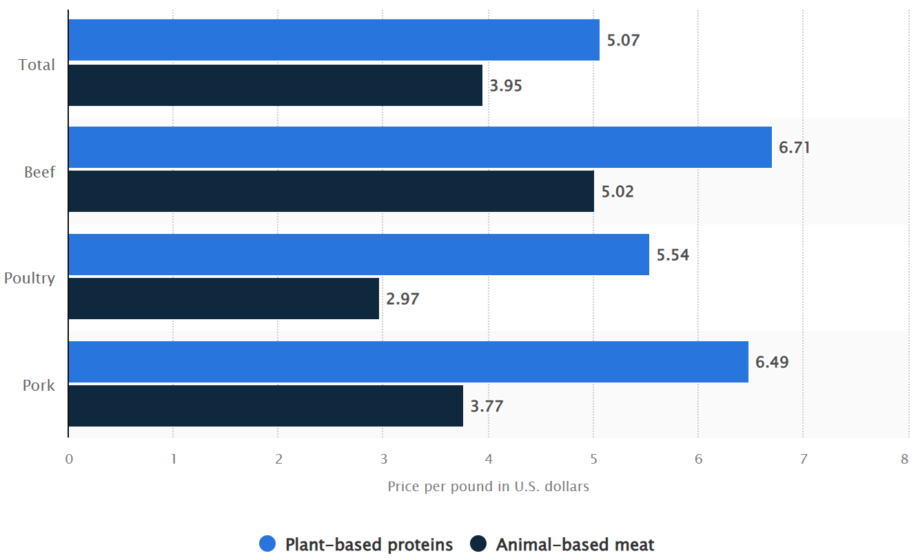

* **Health and nutritional value:** Consumers are becoming increasingly health conscious. In addition, consumers see meat alternatives as healthier than animal-based meat. The combination of these two drives increased consumption of meat alternatives. This is a key consideration for Flexitarians.
* **Product attributes:** Factors like flavor, protein content, packaging, and many more can impact a consumer’s decision to buy a meat alternative.

With these trends in mind, Conagra’s success in the meat substitute space will most likely depend on its ability to tailor its meat substitute products to meet the noted motivations of customers.

1. **Project Objective**

We intend to utilize the provided data provided by Conagra to tailor their meat substitutes brand Gardein to meet the wants and motivations of their current and upcoming customers. We’ve assembled five research questions that are attached below that will assist us in achieving our project objective.

**Research Questions**

**Based on what we know of Conagra and our intention to assist them in increasing the profitability and market share of their Gardein brand, we’ve identified the following research questions regarding flavors and packaging and will be performing in-depth analysis to address them:**

1. **How can Gardein optimize its product portfolio by leveraging data from high-performing flavors while maintaining its clean-label commitment to drive market growth?**
2. **Which flavor and product attributes drive the highest consumer engagement and sales growth in the plant-based meat substitute market, and how can Gardein leverage these insights to optimize its marketing strategy?**
3. **How can Gardein optimize its pricing strategy and consumer engagement to enhance market share and compete effectively with established brands like MorningStar, Beyond Meat and Impossible Foods?**
4. **What is the performance of different packaging types for Gardein and MorningStar?**
5. **Which packaging strategies contribute to Morning Star’s success, and how can Gardein adapt?**

**2. Data Preprocessing**  
The dataset for this project had Fz_Rfg Substitute Meat_POS data files from 2020 to 2024. We started by loading these files into Jupyter Notebook and joined them into one dataset. To enrich the dataset, we merged it with another file, Product Attributes, using the UPC 13-digit code as the key because it was the same in both datasets.

**Filtering and Feature Engineering.**  
To focus on relevant records, we have applied filters in the following columns:  
**1) Product:** Retained only records where the product name starts with "GARDEIN".  
**2) Product Type:** Retained only records labeled as "MEAT SUBSTITUTE".

**3) Geography:** Removed records labeled "Total US - Multi Outlet + Conv", keeping only records for individual regions.

**4)** Using the **"Time"** column, we extracted the Month and Year into separate columns. We then created a new column called "Season" based on the month:  
**Autumn:** Months 9, 10, 11  
**Spring:** Months 3, 4, 5  
**Summer:** Months 6, 7, 8  
**Winter:** Months 1, 2, 12  
After these changes, we removed columns we did not need and kept the following:   
Geography, Product, Dollar Sales, Price per Unit, Package, Form, Total Ounces, Flavor / Scent, Month, Year, Season.

**Handling Missing Data and Skewness:**  
We looked for missing values and found that there were none. Then, we checked the skewness of the numerical variables:  
The Total Ounces and Price per Unit were found to be imbalanced, so we employed Standard Scaling to make their distribution uniform.

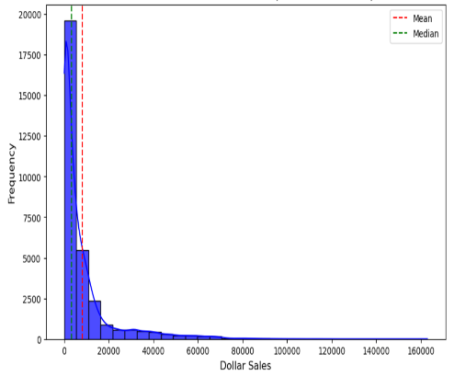 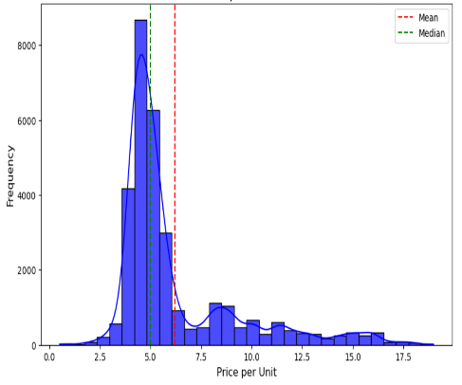 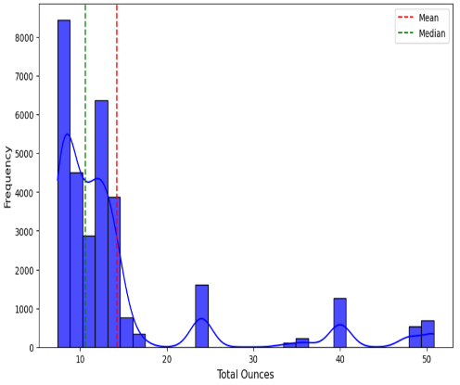

**Categorical Encoding:**  
We used Target Encoding for the categorical variables to convert them into numerical forms while preserving their relationship with the target variable.

**Final Model Input:**  
Dependent Variable: **Dollar Sales**  
Independent Variables: All other columns, both categorical and numerical features.  
This preprocessing workflow ensured the dataset was organized, tuned, and ready for use in training and analysis.

**Model**

This analysis will attempt to predict Dollar Sales based on some features of product characteristics, package details, and geographical data using linear regression.

Temporal order was ensured by sorting the dataset on the Year and Month attributes, simulating a real-world setting where the model must predict targets from previous data. The data were divided into 70% for training and 30% for testing.

Both the training and testing sets were used to make scaled Dollar Sales predictions using this model. These scaled predictions were transformed back to their original scale for evaluation and visualization.

 

The results suggest that the model accounts for about 75% of the variability in the test set and generalizes similarly for the training data. Overall, performance metrics coupled with the scatter plot show that the model is well-calibrated and is not overfitting.

**3. Data Analysis for Research Questions and Marketing Strategies**

**2020:**

**2021:**

**2022:**

**2023:**

**2024:**

**Gardein Flavor Performance Analysis (2020-2024)**

**Consistently Underperforming Flavors:**

* Phased out: Classic, Garden, Italian Sausage, Maple Sausage, Black Bean Chipotle, Sweet & Tangy, Spicy.

**Strong Performers:**

* Chicken flavor, Regular meat substitute, 7 Grain.

**Market Exit Insights:**

* Poor performers (bottom tier for 2–3 years) were discontinued, reflecting Gardein’s responsive product lifecycle strategy.

**Success Indicators:**

1. Mainstream Appeal: Simple, familiar flavors succeed (e.g., chicken, meat substitute).
2. Simplicity: Complex flavors (e.g., Portobello, Black Bean Chipotle) underperform.
3. Versatility: Multi-application products perform better.

**Strategic Recommendations:**

1. **Optimize Product Line:** Focus R&D on strong performers; discontinue underperformers.
2. **Clean Label Innovation:** Develop clean, mainstream flavors; leverage the current clean label advantage.
3. **Flavor Development:** Prioritize versatile, familiar flavors like chicken nuggets. Experiment with globally inspired (e.g., Teriyaki, Spicy BBQ) or seasonal flavors.
4. **Partnerships:** Collaborate with fast-casual chains to promote top flavors.
5. **Retail Strategy:** Use predictive data analysis to expand into high-demand regions.

**Advantages:**

* Reduced costs by eliminating poor performers.
* Strengthened focus on bestsellers.
* Improved production efficiency and alignment with consumer preferences.

Competitor analysis reveals Gardein can emulate the focused, high-impact strategies of Beyond Meat and Impossible Foods to capture greater market share.

**Competitive Research: Key Differences and Market Position Analysis**

1. **Product Variety vs. Focused Selection:**
   * Gardein: Offers various products and flavors, providing options but risking diluted brand identity and increased production complexity.
   * Competitors (e.g., Impossible Foods, Beyond Meat): Focus on fewer, high-quality products, simplifying branding and improving taste and texture.
2. **Consumer Perception and Quality:**
   * Impossible and Beyond Meat: Positioned as premium brands closely replicating meat taste and texture.
   * Gardein: Lacks a distinct identity due to its extensive product line.
3. **Flavor Preferences and Consumer Trends:**
   * Consumers prefer traditional, familiar flavors (e.g., chicken, beef, bacon, BBQ) paired with clean-label ingredients.

**Morningstar Comparison:**

* Morningstar offers a curated range of 30+ flavors that perform well in the market, demonstrating the effectiveness of a balanced and focused product line.

**MorningStar vs. Gardein: Key Comparisons**

1. **Streamlined Product Line:**
   * **Balanced Variety:** MorningStar balances product diversity with curated, crowd-pleasing options like breakfast patties and nuggets, aligning with mainstream tastes.
   * **Consumer-Friendly Flavors:** MorningStar focuses on familiar, versatile flavors (e.g., classic breakfast items, meat-like substitutes), avoiding niche overload. Their original meat substitute is a bestseller.
   * **Effective Branding:** Established in 1974, MorningStar enjoys strong brand recognition and a leading position in household purchases (17.2% penetration in frozen meat substitutes).
2. **Pricing and Accessibility:**
   * **Affordable Pricing:** Competitive prices with frequent promotions increase accessibility and encourage trials.
   * **Strategic Placement:** Prominent freezer placement in mainstream and discount stores ensures visibility and easy recognition.
3. **Health-Focused & Sustainable Positioning:**
   * **Clear Messaging:** MorningStar emphasizes health and sustainability, targeting environmentally conscious consumers with initiatives like vegan certification and water reduction.
   * **Breakfast Niche:** Their strong focus on breakfast items, like veggie sausages and patties, fills a market need for convenience.

**Implications for Gardein:**

* **Boost Engagement:** Increase consumer engagement via targeted marketing, social media content, and partnerships.
* **Competitive Pricing:** Offer promotions and competitive pricing for popular products to attract and retain consumers.
* **Leverage Clean Label:** Highlight clean-label benefits (no artificial ingredients, trans fats, or MSG) to appeal to health-conscious buyers.
* **Expand into Breakfast:** Explore high-demand breakfast products to capture untapped niches.
* **Streamline Lineup:** Focus on high-performing flavors and discontinue persistently underperforming ones.

**Gardein**

**Morning star**

**Gardein in 2023**

**Morning Star in 2023**

**In Gardein brand: 2020 vs 2023**

**Forms Performing Well:**

1. Ground: Dominates with resealable plastic bags in 2020; shifts to cost-effective plastic bags in 2023.
2. Meatball: Strong initial performance with resealable plastic bags but transitioned away in 2023 due to low impact.
3. Burger: Balanced use of plastic bags and boxes; boxes preferred in 2023 despite slight sales decline.
4. Filet: Surged in 2023, favored for resealable plastic bags due to consumer preference for convenience.

**Forms Performing Poorly:**

1. Slider, Sliced, and Strip: Show limited appeal due to packaging and design misalignment.
2. Tip and Bite: Low sales despite initial use of resealable bags, indicating a lack of innovation in packaging.

**Packaging Performance:**

1. Resealable Plastic Bags: Performed well in 2020, especially for high-volume forms, but lost ground in 2023.
2. Plastic Bags: Dominated in 2023 as a cost-effective alternative for "Ground" and "Meatball."
3. Boxes: Underperforming but preferred for specific forms like "Burger."

**Weaknesses of Gardein**:

1. Underperforming Forms: Products like "Slider" and "Tip" dilute focus and resources.
2. Packaging Choices: Box packaging needs innovation but shouldn’t be eliminated.
3. Cost-Effective Focus: Over-reliance on cost reduction rather than sustainability.
4. Product Breadth: A wide range of low-performing forms reduces operational efficiency.

**Strategic Recommendations:**

1. Focus on High-Performers: Prioritize "Ground," "Meatball," and "Filet" with targeted marketing and packaging innovation.
2. Streamline Portfolio: Discontinue low-performing forms like "Slider" and "Tip."
3. Advance Packaging: Maintain resealable bags for premium forms and explore sustainable alternatives to strengthen brand trust.
4. Sustainability: Launch eco-friendly packaging (e.g., biodegradable resealable bags) to attract environmentally conscious consumers.

**Strengths of MorningStar:**

1. Burger Dominance: Leads in unit sales with effective resealable plastic bag packaging.
2. Innovative Packaging: Plastic containers in sleeves (e.g., Breakfast Sausage Patty) add premium value.
3. Trend Adaptation: Successfully taps into emerging segments like "Crumble."

**Opportunities for Gardein:**

1. Leverage Resealable Bags: Focus on high-volume forms like "Ground" and "Burger Patty."
2. Innovate Packaging: Introduce sustainable, premium packaging for "Meatball" and "Filet."
3. Sustainability Focus: Differentiate with eco-friendly packaging to capture market share in the sustainable food category.

**Sustainability Options:**

Eco-Friendly Packaging Options

Biodegradable Resealable Bags

Recyclable Packaging Materials

Post-Consumer Recycled (PCR) Materials

Plant-Based Plastics

Edible Packaging

Minimalist Packaging

**Sustainability Messaging Suggestions:**

1. Certification and Labels: Obtain certifications like FSC (Forest Stewardship Council) for paper products or "Compostable Packaging" certifications for biodegradable options. Use labels like "100% Biodegradable," "Made from Recycled Materials," or "Plastic-Free Packaging" to build consumer trust. Build trust in consumers by assuring them every small detail of their health was considered in making and selling the product.
2. Highlight the Environmental Impact: Communicate how much waste the new packaging reduces, how it contributes to reducing carbon footprints, how it supports a sustainable future and how the brand is conscious of protecting society’s interest, this helps the consumer connect better with the brand and its value.
3. Input information about the brand: Add QR codes on packaging that lead to educational content about sustainability efforts, recycling tips, and the environmental benefits of choosing Gardein.

**Gardein**

**Gardein**

**Morning star**

**Morning star**

**Gardein**

**Morning star**

**Gardein**

**Morning Star**

**Gardein**

**

**Key Takeaways:**

1. **Plastic Bags Losing Steam:** While dominant, their declining relevance shows the need for more sustainable alternatives.
2. **Resealable Plastic Bags Emerging as Key Drivers:** These are popular among premium and convenience-focused consumers, with growing sales showcasing their value.
3. **Boxes Are Not Competitive:** Poor performance means that either redesigning them sustainably or phasing them out is needed.

**Strengths in Packaging:**

1. **Plastic Bags Versatility:** Affordable and widely accepted across forms.
2. **Resealable Plastic Bags:** High consumer preference, as it offers long-term potential for premium products.

**Weaknesses in Packaging:**

1. **Overreliance on Plastic Bags:** Risks alienating sustainability-conscious consumers.
2. **Underutilization of Resealable Packaging:** Missed opportunities for premium forms like "Burger Patty".

**Strategic Recommendations for Packaging:**

1. **Focus on Resealable Plastic Bags:** Prioritize high-performing forms (e.g., "Ground," "Meatball," "Filet") and expand use in "Burger" products.
2. **Introduce Eco-Friendly Packaging:** Launch biodegradable resealable bags for premium products and recyclable options for cost-effective forms.
3. **Redesign Box Packaging:** Utilize recyclable or compostable materials to promote eco-conscious appeal and support sustainability objectives.
4. **Develop Marketing Around Packaging:** Highlight packaging reliability and sustainability in advertising to build consumer trust.
5. **Tiered Packaging Strategy:** Use cost-effective bags for entry-level products and eco-friendly packaging for premium items.

**Observations: Gardein vs. MorningStar:**

* **Gardein:** Relies on limited packaging options (plastic bags, resealable bags, boxes) with minimal focus on sustainability.
* **MorningStar:** Offers innovative and diverse packaging (e.g., resealable peg bags, vacuum-sealed containers) with recycling initiatives.

**4. Conclusion**

**Strategic Emphasis: Flavors and Packaging are the Sustainable Growth Drivers**  
 Gardein is at an important juncture to recreate its marketing strategy based on consumer preference for health, sustainability, and trust. From this analysis, success seems to be based on aligning product offerings with innovative packaging that caters to evolving consumer demands.  
  
**Flavor Balancing: Health, Simplicity, and Sustainability**  
 To resonate with health-conscious consumers, Gardein needs to streamline its flavor lineup by promoting well-performing, familiar options such as Chicken and BBQ while phasing out underperformers like Garden, Black Bean Chipotle, and Sweet & Tangy. The company should be shifting its focus toward clean-label products that use organic, sustainably sourced ingredients. Transparency, inspired by MorningStar’s approach, is crucial—adopting a “farm-to-table” narrative that shares how ingredients are grown and processed will build trust and brand loyalty. Exploring globally inspired, yet simple flavors like Teriyaki or Spicy BBQ can tap into emerging consumer preferences and diversify Gardein's portfolio.  
  
**Packaging: Leveraging Sustainability for Competitive Advantage**  
Sustainability has emerged as a cornerstone of consumer trust. Gardein should focus on recyclable and biodegradable materials for packaging, embracing innovative solutions such as resealable bags and vacuum-sealed options for premium products. Though boxes currently underperform, they need to be redesigned using sustainable materials for niche uses, mainly for products such as burgers. Packaging should over-emphasize eco-conscious efforts, from labels such as "100% Recyclable" or "Sustainably Sourced" to messages emblazoned on the front: "Healthier You, Healthier Planet." It creates transparency in consumer values and positions Gardein as a responsible brand.  
  
**Building Consumer Trust Through Branding**  
Gardein needs to strengthen its brand identity by incorporating its sustainability message into marketing campaigns. Catchy taglines like "Good for You, better for the Earth" would emotionally connect with consumers. Transparency will be built-in packaging design, health benefits, and ingredient sourcing, which will engender trust and loyalty. Offering rewards for recycling participation, such as discounts or loyalty points, further demonstrates a commitment to sustainability and encourages eco-conscious behaviors.

**Operational Smoothing for Market Leadership**  
Simplification of the product portfolio by focusing on high-performance flavor and packaging types will not only enhance operational efficiency but also bring Gardein's portfolio in line with consumer demand. This will be achieved by phasing out underperforming products and investing in flavors and packaging that reflect health and sustainability. By emulating the focused strategies of Beyond Meat and MorningStar, Gardein will ensure competitiveness in this market.  
  
**For long-term growth, Gardein needs to:**  
Focus on clean-label, health-conscious flavors with transparent sourcing. Innovate with sustainable packaging while maintaining functionality and appeal. Invest in branding and consumer education campaigns highlighting health and sustainability. Implement eco-friendly programs such as recycling programs or reusable packaging to build loyalty. By putting the power of flavor and package strategy aligned with the same priorities of consumers, Gardein can further fortify its position in the marketplace through trust and become a leader in the plant-based food market for sustainable and profitable growth.

**References**

<https://www.precedenceresearch.com/press-release/refrigerated-display-cases-market>

<https://www.statista.com/statistics/1449663/average-meat-and-meat-alternative-prices-in-foodservice/>